  - Is this the story behind Bayard's Colts?

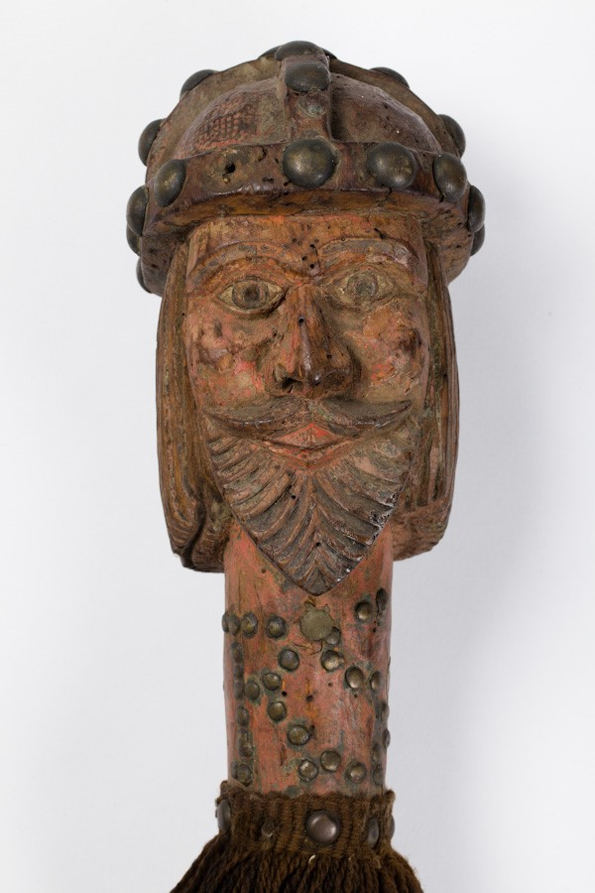
Bayard was a ‘super-horse’, a magical beast, in a legend about the 9th-century emperor Charlemagne who ruled over a large part of Western Europe. He belonged to Renaud of Montauban, the son of Duke Aymon, a noble at Charlemagne’s court. Renaud and his three brothers (in full armour) could all ride on Bayard’s back at once. Charlemagne’s nephew Bertolai quarreled with Renaud over a game of chess and struck him. The emperor refused Renaud justice and the quarrel escalated, ending in Renaud killing Bertolai. The four brothers fled the court. The bulk of the narrative deals with the bitter war between these rebellious barons and Charlemagne. One episode (reminiscent of Robin Hood) tells how Charlemagne held a horse race: magically transformed, Renaud and Bayard turned up looking like a nag and a young boy – but easily won the race before escaping. The wars end with reconciliation.
The Charlemagne head
The legends of Charlemagne were very popular in medieval England and there is some evidence of particular interest in the Midlands area. Th e story of Renaud and Bayard circulated in French verse. French was an important language among the elite in England during the Middle Ages, but there is no evidence of it in English before 1489 when it was translated by the pioneering English printer William Caxton.
The origins of the Bayard’s Colts – a collection of 17 staffs in the custody of Walsall Leather Museum – have intrigued people for centuries. The current ‘Colts’ probably date from around the 17th century but the tradition relating to them goes back further than this. Some of the staffs have carved heads (horses, men, devilish monsters, a lamb), while others end in weapons. They were used in ceremonial processions until the mid-19th century. It is easy to imagine them having both a ceremonial purpose and serving to impose law and order. After the processions were abandoned the Colts were hung on the wall of the Magistrate’s Court. This link with the dispensing of justice would be appropriate as the medieval story of the horse Bayard and his owners focused on the thorny issue of how a man should behave if his lord/king behaved unjustly towards him.

